**TEMPLATES**

**1.EMPATHY MAP**

**2.BRAINSTORMING MAP**

**3.DOWNLOAD TABLEAU**

**4.DOWNLOAD DATASETS**

**5.CONNECTED DATASETS**

**6.CREATE VISUALIZATION**

**7.CREATE DASHBOARD**

**8.CREATE STORY**

**9. PUBLISH DASHBOARD AND STORY**

**10. CREATE PROJECT REPORT**

**11. CREATE DEMO VIDEO**

**1.EMPATHY MAP**

**First I create empathy map. This empathy map is about say, think, does, feel. I told that in say place Lok Sabha Elections 2019. I told that in think placehow was the election conducted and I told in does place what changes can be made in elections and I told in feel place things I worry about in elections.**

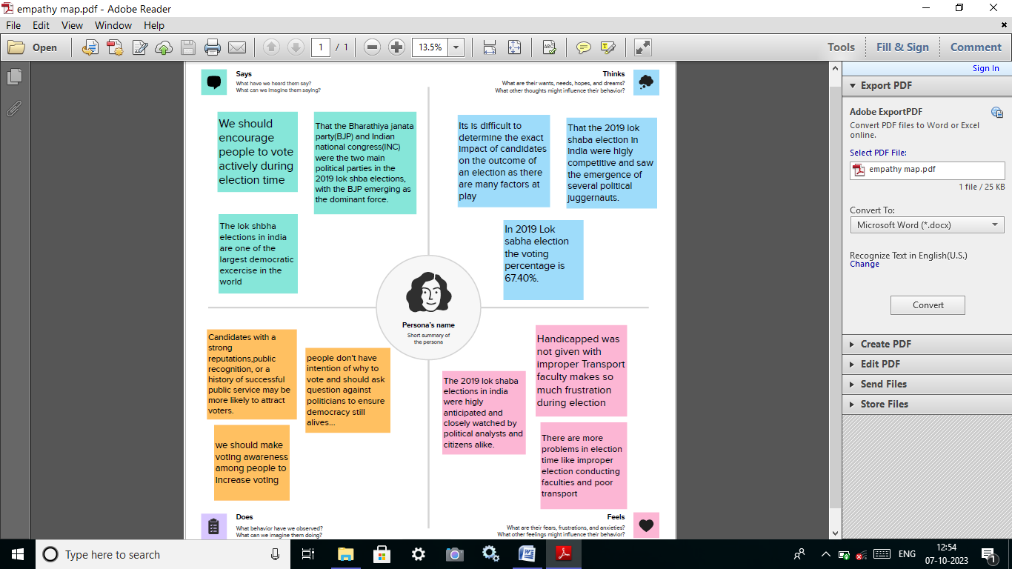

**2.BRAINSTORMING MAP**

**First I found the problem of Lok Sabha Elections 2019 and discuss our problem and find solution ideas. Next I collect the solution ideas add the brainstorming map.**

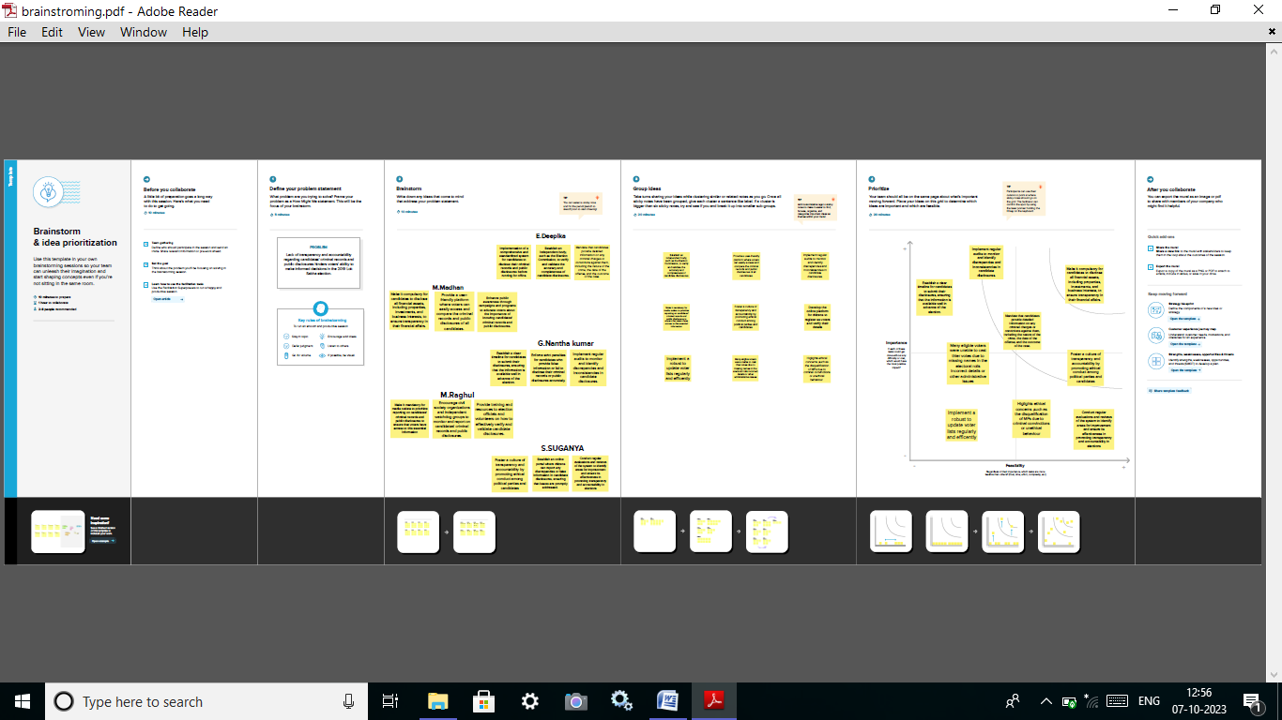

**3.DOWNLOAD TABLEAU**

**Tableau provides three versions of Tableau Desktop [4]. The Public version is free but the Personal and Professional versions are available with a fee or free 14-day trial. However, Tableau provides a 1-year free product key with support for students and instructors in academic programs.**

**4.DOWNLOAD DATASETS**

**I downloaded dataset using the above link**

[**https://drive.google.com/file/d/1f0Q_AohNA8PQ8AL6WXYyIw-kgoVkGDmd/view**](https://drive.google.com/file/d/1f0Q_AohNA8PQ8AL6WXYyIw-kgoVkGDmd/view)

**DATA CHARACTERSTICS**

1. State: It is Dimension in LG Data, which represents State names.
2. **CONSTITUENCY:** It is also Dimension shows the constituency of states.
3. Name: participates names from their party.
4. **Party**: name of the party.
5. **Symbol:** party symbol.
6. **Gender:** gender of the participants.
7. **Criminal Cases:** cases on party participants.
8. **Educational qualification:** Voter’s education.
9. **Category:** it shows their category like BC, Sc OBC
10. **Winners:** it is a measure that shows the winners in the data.
11. **Age:** It shows the age Candidates.
12. **Assets:** it shows the assets values of the states.
13. **Liabilities:** it shows the all liabilities of the states.
14. **General Votes:** It shows the total general votes.

**15.Postal Votes:** postal votes from the country.

**16.Total Electors:** total count of electors in a country.

5.CONNECTED DATASETS

I connected my datasets using the explanation video

[**https://drive.google.com/file/d/1enGl9c4jOhG-HuP4J5fo4usI5rRqf6ub/view?usp=sharing**](https://drive.google.com/file/d/1enGl9c4jOhG-HuP4J5fo4usI5rRqf6ub/view?usp=sharing)

**6.CREATE VISUALIZATION**

I create the data visualization sheets: KPI’s,**Gender & educational Wise General Votes, State wise Winner, State wise General Votes and Postal Votes, State wise Criminal Cases, constituency wise Winners and Electors, Party wise Winner, Winners by Education and Category, Party Wise Postal Votes.**

**7.CREATE DASHBOARD**

**I create dashboard using the data visualization sheets**

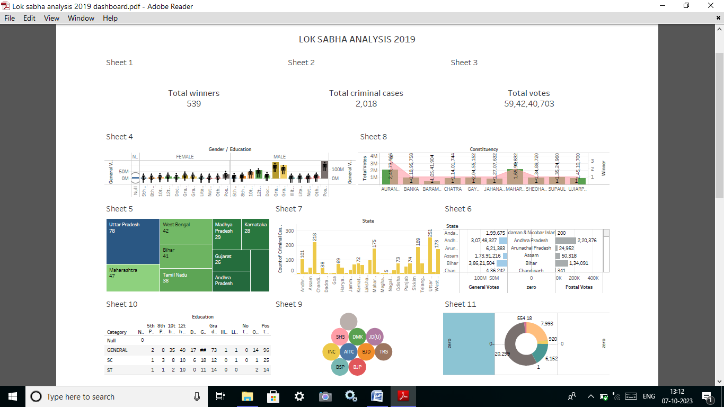

**8.CREATE STORY**

**I create story using data visualization sheets**

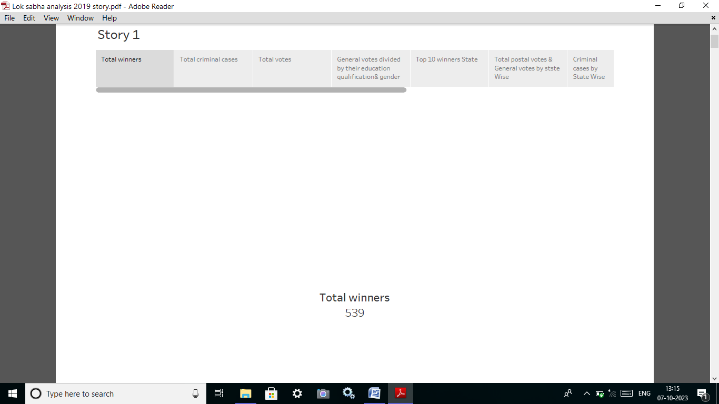

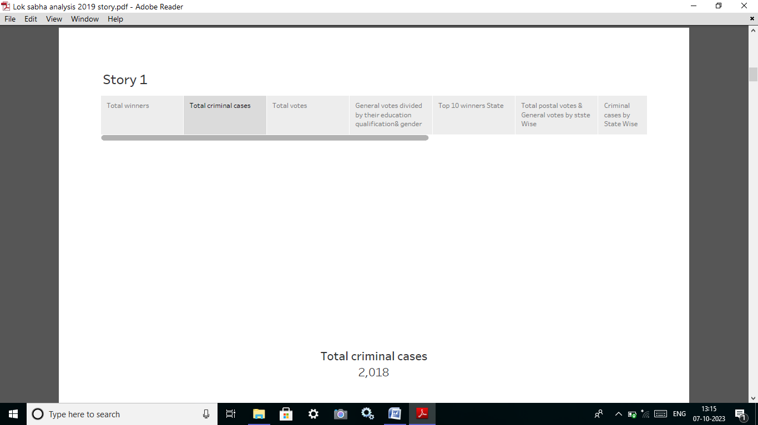

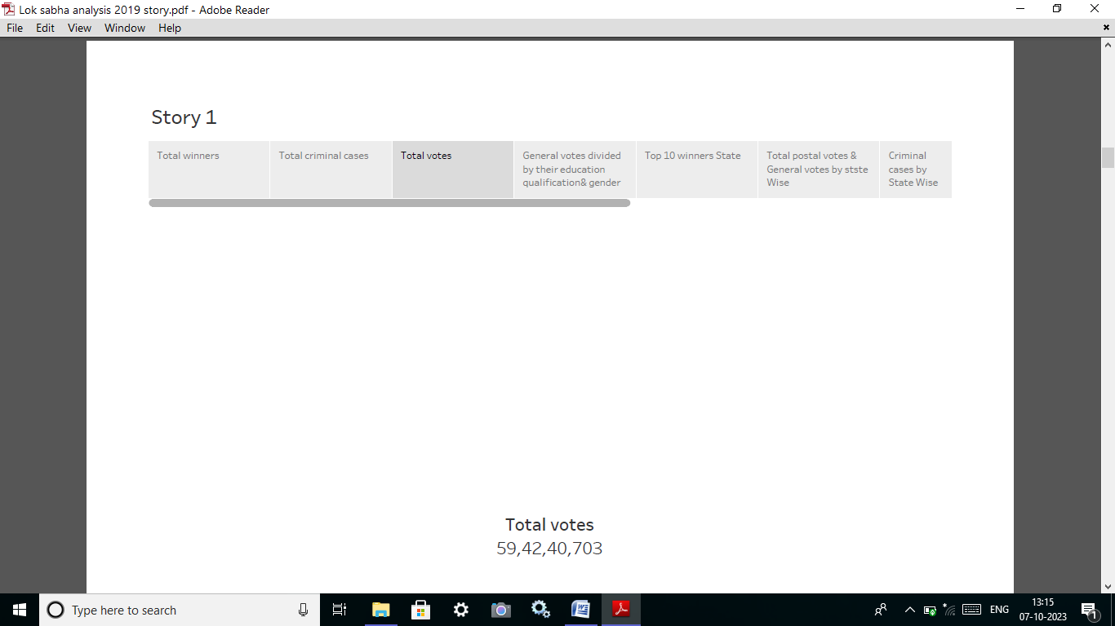

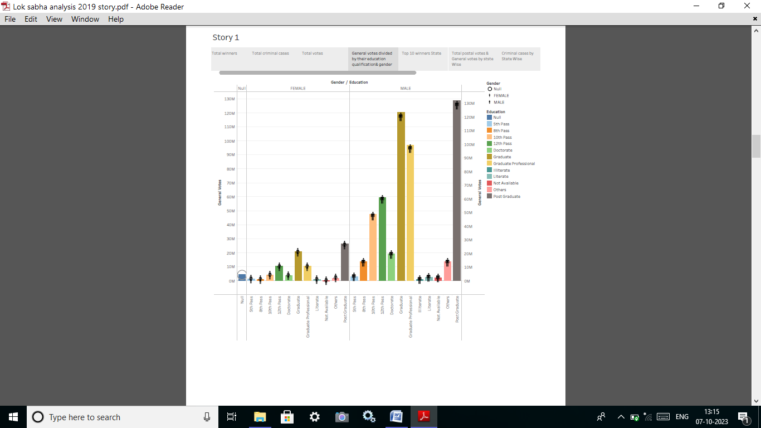

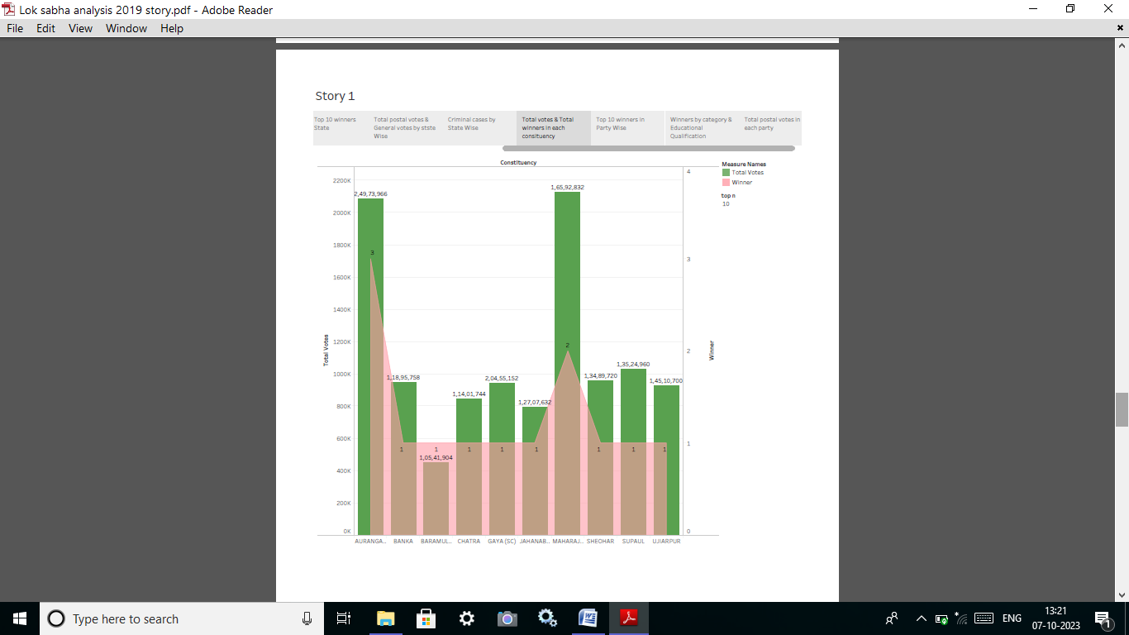

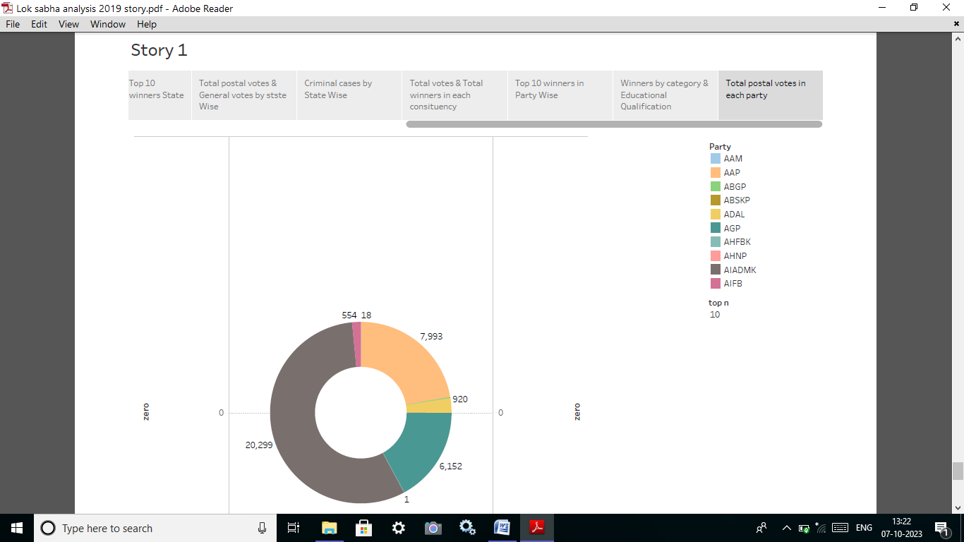

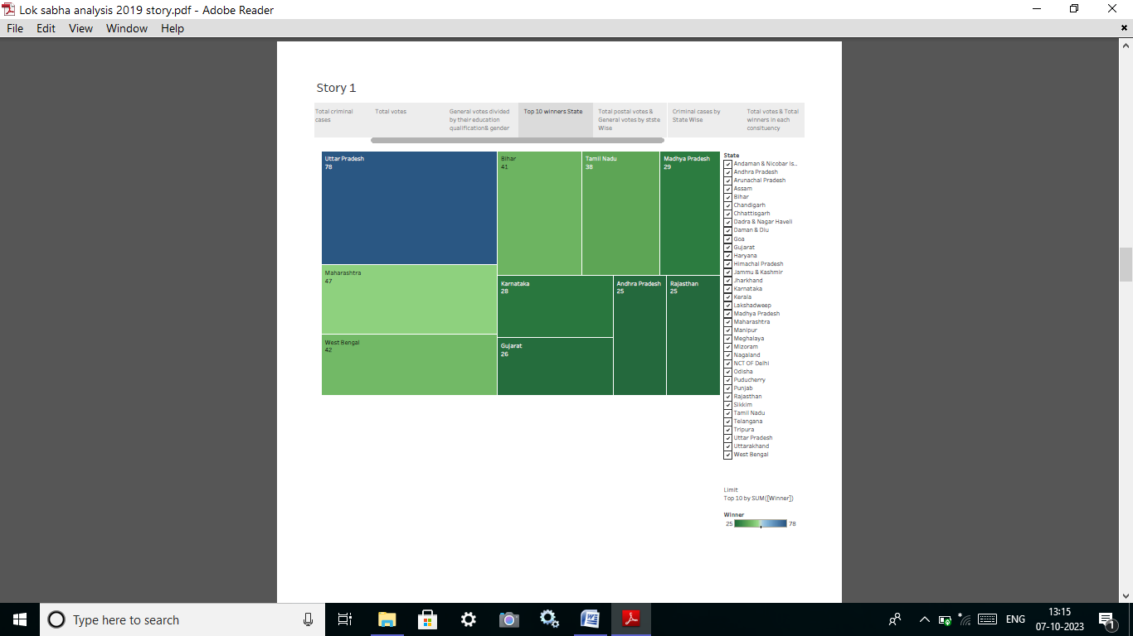

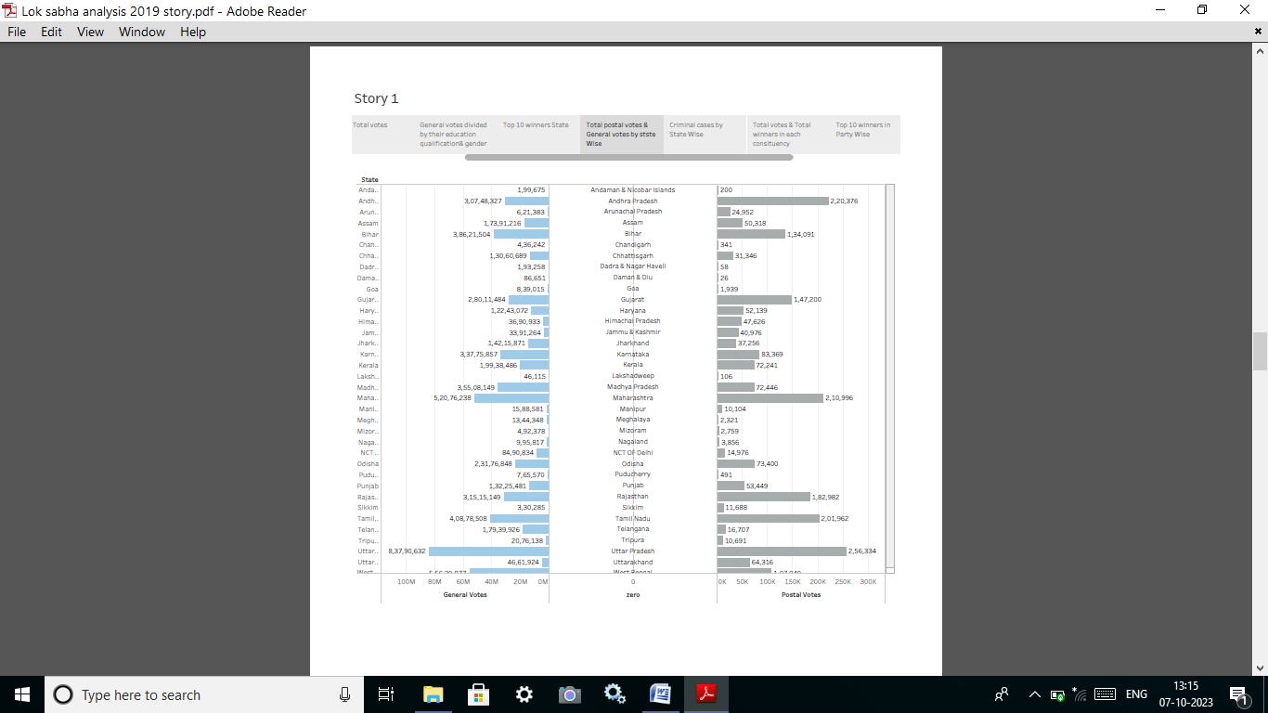

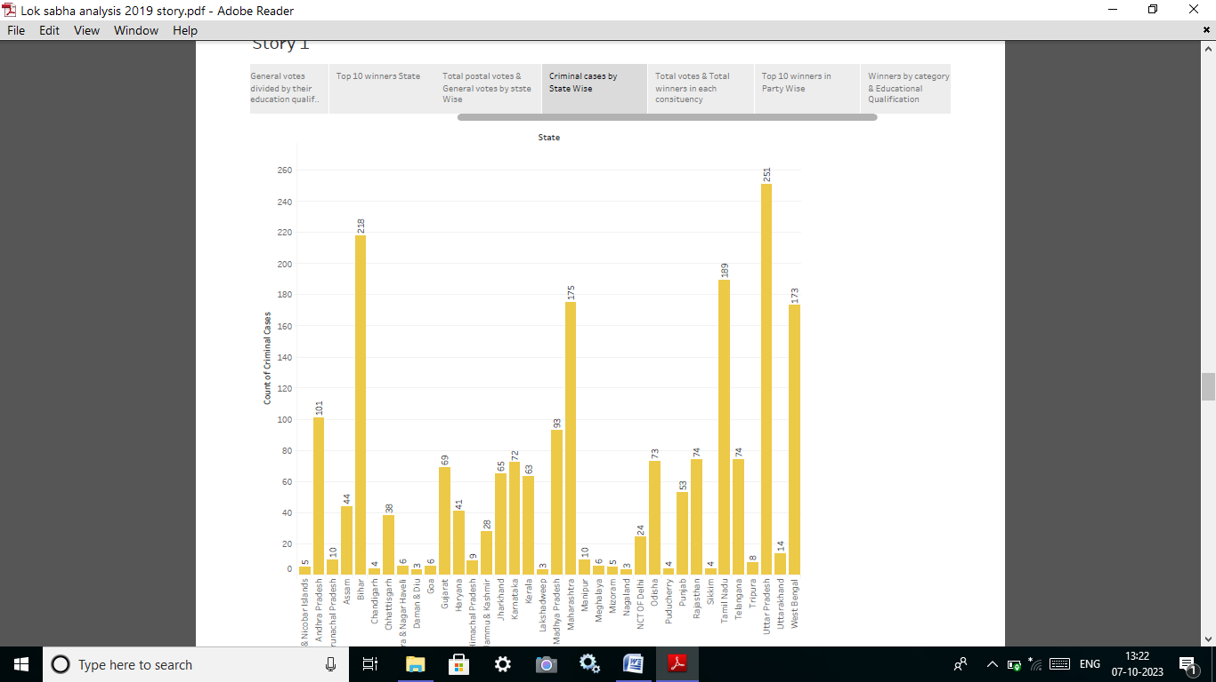

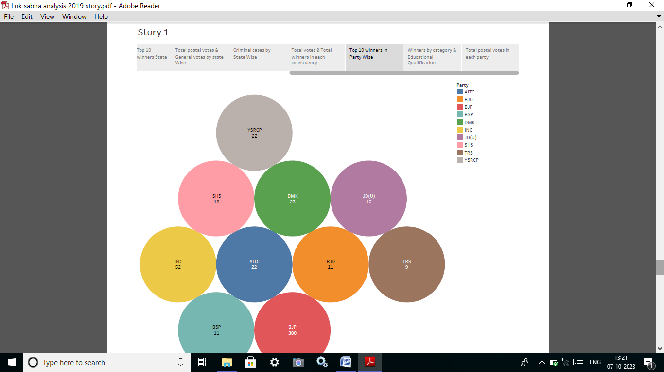

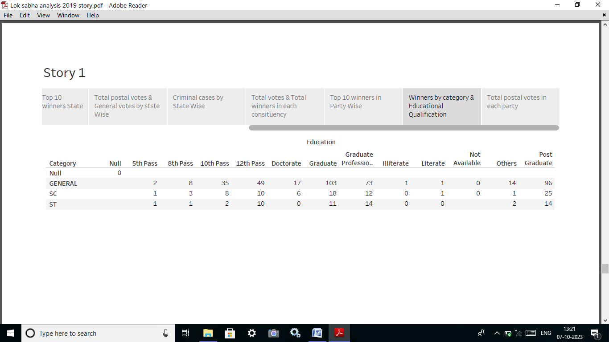

**9.PUBLISH DASHBOARD AND STORY**

I publish dashboard and story in tableau public

Using the explanation video

[**https://drive.google.com/file/d/1N7LRbdJ-lO47tM77W_5XMFCmDMF2FISr/view?usp=drive_link**](https://drive.google.com/file/d/1N7LRbdJ-lO47tM77W_5XMFCmDMF2FISr/view?usp=drive_link)

**10.CREATE PUBLIC REPORT**

**I create my project report step-by-step project process.**

**11.PROJECT DEMO VIDEO**

**I record project demo video step-by-step project process.**

